# Career Planning

# Importance of Career Development for students:

In today’s world where there is competition, clutter and varied options. It is very important to have career development on your agenda and to invest time and effort in finding what you want to do and what path you will be taking to be there. It is being goal oriented.

There is no doubt that there will be twist and turn on the journey, surprises and pivots that may lead you to another end. It can all happen if you are a journey. So, career development should be introduced to students early and they be taught as to how to create this in their life and follow it.

Support infrastructure is also important in this, the ecosystem must support the student in the path chosen and make available tools, mentoring and guidance to keep them on track.

It assists students to make decisions at key transition points and supports their successful transition from school to further education or work. It also aims to +

develop the career management competencies that will equip students to manage their career pathways and opportunities throughout their lives.

(i) Introduction to Career Development

It is the lifelong pursuit of managing learning, work, leisure, and transitions in order to move forward to a personally determined and preferred future:

**What is a career?**

• a series of jobs or positions held by an individual

•series of work-related activities pursued by an individual

•it is shaped by factors such as: Job/work performance, Educational qualification, Work experience, Networking abilities, Additional training, Fortune

In more elaborate way to say is:

The progress and actions taken by a person throughout a lifetime, especially those related to that person's occupations. A career is often composed of the jobs held, titles earned and work accomplished over a long period of time, rather than just referring to one position.

While employees in some cultures and economies stay with one job during their career, there is an increasing trend to employees changing jobs more frequently. For example, an individual's career could involve being a lawyer, though the individual could work for several different firms and in several different areas of law over a lifetime.

Purpose:

A good career is financially or otherwise rewarding, and it meets your skills and interests. Only some people in this world will work at jobs they like; so become one of them, by building your strengths and broadening your interests while young, then testing the available jobs to see what suits you.

**What is Career Planning? It is the outcome of:**

•constantly thinking about one’s interests, values, skills, and preferences

•exploring the life and learning options available to one

•ensuring your work fits with your plans

manage changes in life and work by continuously fine tuning your work

Career planning can be defined as a systematic process by which one decides his/her career goals and the path to reach these goals. For example, one young man decides upon an academic career and establishes the following sequence of positions.

(1) Ph. D. degree by age 26,

(2) Lecturer by 27,

(3) First book published by 30,

(4) Reader by 35,

(5) Professor and the head of the department by 40,

(6) Dean of the school by 45, and

(7) Vice Chancellor of a university by 55.

**(iii) Need for Career Planning**

• with the right opportunity, a person may be able to achieve success

• with the right encouragement the employee may be motivated to meet personal goals

Why is career planning important for students?

Importance of Career Planning. It is important to come up with your career planning as it gives you the much needed direction and makes it clear there where you see yourself in future. It makes you aware of your strength and weaknesses and the skills and knowledge that are required to achieve your goals in future.

Students that follow the strategies listed below will be better prepared to promote themselves to employers.

* Visit your college career and placement services. ...
* Assess yourself. ...
* Explore careers related to your degree. ...
* Participate in career activities. ...
* Position yourself. ...
* Be a success in the workplace.
* Appreciate the benefits of college.

[Higher education pays off](https://careerwise.minnstate.edu/education/educationforyou.html). Increasing your skills is more than just a trendy thing to do. It's a way to increase your earning power and employability throughout your career.

**(iv) Tips for Job Hunting**

•list all your achievements

•enlist the help of all your contacts

•prepare a good resume

•Respond positively to queries

•Prepare and plan for your interview

•Avoid being over accommodating

•Negotiate terms and conditions

Some more Job Hunting Tips for Students

1. Be realistic. ...
2. Work to keep your resume at a single page. ...
3. Show a willingness to work for free for experience.
4. Stay focused on your studies.
5. Research a company and position before interviewing with them.
6. Don't give up on getting a reference. ...
7. Keep up with your reference list.

**(v) Career Stages**

Exploration

Establishment

Mid Career

Late Career

Decline

1. **Exploration:** The exploration stage is the pre-employment stage, wherein the individuals are in their mid-twenties and enter from their college life to the work environment. The individuals narrow down their work preferences on the basis of the directions shown by their parents, friends, family, teachers.

At this stage, several expectations about the work are created that may be the fantasies, or unrealistic beliefs about the work, very much before entering into the firm.

1. **Establishment:** At this stage, an individual actually experiences the work culture in his first job. Here, all the expectations and fantasies come to an end, and one has to face the reality of life. This stage covers about 10 years from the 25 years of age.

It is also called as a learning stage; wherein the fresher learns under the guidance of a mentor. At this stage, the fresher commits many mistakes and try to learn from these, thereby gaining a position in the society and working for his career advancement.

1. **Mid-Career:** This stage covers the age period of 35 to 45 years. At this stage, the individual is no longer considered to be a fresher and his mistakes are taken seriously by the senior management.

Here, the employee must evaluate his current career position, i.e. whether he is advancing, or has stabilized or has started to decline and look for the future career prospects. At this stage, an individual has to maintain a balance between his career and his personal life i.e. spouse and children.

1. **Late-Career:** At this stage, an individual reaches to a particular position in the organization hierarchy, on the basis of his career graph which is characterized by growth or stagnation.

If an individual grows even after the mid-career (i.e. 20 years after mid-forties), then he is considered to be having the pleasant experience with the work. Here, an individual becomes the mentor and guide others through his experiences.

1. **Decline:** This is the last stage of career development. At this stage, an individual has to step out of his work or get a retirement from his official commitments. It is considered as one of the difficult stages, as it is very hard for the employees to leave the firm who are doing excellent even after their late career.

Thus, every individual passes through these five stages of career development as they move along their life cycle.

Top of Form

Bottom of Form

**(vi)Steps to Successful Career Planning**

Know

Discover

Decide

Act

* Step 1: Get to know yourself. Identify your vision, values, interests, skills, traits and abilities. ...
* Step 2: Explore your occupational options. Explore your options and gather information about them. ...
* Step 3: Get ready by evaluating your career options. ...
* Step 4: Take action to achieve your career goals.

**(vii) Career Exploration Career exploration is the process of :**

Discovering yourself and the world of work

Identifying and exploring prospective rewarding occupations

Developing a successful strategy to achieving your goals

Begin your process of self-discovery by reflecting on the following questions:

* What are my interests and what do I enjoy learning about?
* What do I like to do and what skills would I like to develop?
* What are my talents and strengths?
* What are my values?

**Career Plan Cycle**

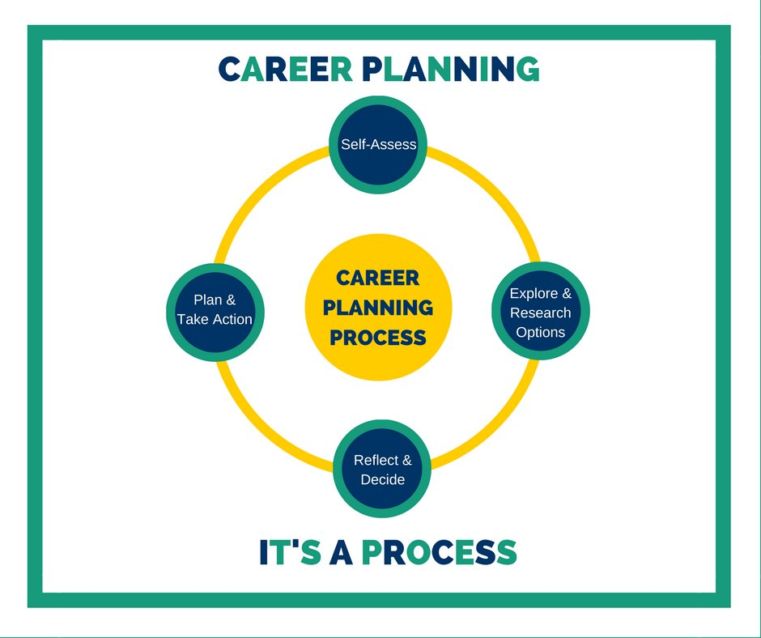

* Step 1: Get to know yourself. Identify your vision, values, interests, skills, traits and abilities. ...
* Step 2: Explore your occupational options. Explore your options and gather information about them. ...
* Step 3: Get ready by evaluating your career options. ...
* Step 4: Take action to achieve your career goals.

**How to Choose a Career**

Individual characteristics that influence career selection are:

* Interests
* Self-image
* Personality
* Social background

**iii) Guidelines for Career Planning**

Set a Clear Career Goal

Explore Career Options

Overcome Career Roadblocks

Execute your Plan

To have a successful career planning, here are 10 tips you should follow.

* Take a look at your pastimes and hobbies. ...
* Note past accomplishments. ...
* Trace your path 'til the last career planning. ...
* Likes and Dislikes, Needs and Wants. ...
* Plan your career annually. ...
* Look for transferable skills. ...
* Research further career job opportunities.
* Never stop learning
* Review Career and Job trends

**(iv) Advantages and Disadvantages of Career Planning**

Advantages:

Benefits to employee: The employee is aware in advance of job opportunities within the organization.

Benefits to organization: Organizations can make informed decisions. Star performers can be fast tracked while slow ones can be put on training.

Relations: It will improve relations between employers and employees. Employee skills can be leveraged.

Disadvantages:

Not suitable for organizations having limited number of employees and opportunities.

Factors such as government policies, laws of the land, reservation/quota can be detrimental to the development efforts.

Lack of the organization’s proper focus can create other problems such as minority groups, forced lay-off, post retirement issues, etc.

**A Success Story:**

Chanda Kochhar (born 17 November 1961) is the managing director (MD) and chief executive officer (CEO) of ICICI Bank. ICICI Bank is India's largest private bank and overall second largest bank in the country. She also heads the Corporate Centre of ICICI Bank.

**Summary**

✓A career is a series of jobs or positions held by an individual during the course of a

lifetime.

✓An individual can shape, modify, reconstruct and build their careers. ✓People tend to choose careers that match their interests.

✓Career planning helps an individual manages his learning on development. ✓Career exploration is the stage where one makes the transition from campus to corporate life.

✓Career planning requires an individual to focus time and effort to come up with the right choices.

✓When trying to achieve a goal it is possible to encounter barriers.

Career planning is designed to help you find and succeed in a career that you love and that meets your needs. Some students enter the major in the career exploration stage, where they need to learn about different careers and figure out which one they will pursue.

Others enter the major committed to a specific career, and they focus on developing the skills and knowledge they will need for that career. In reality, students often move back and forth between exploration and commitment. For instance, once students find a broad occupation, they do more exploring to see which specialization they like.